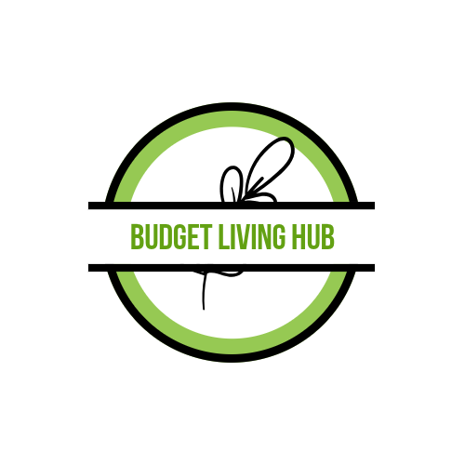

Budget Living Hub
  - Helping you save money, live smarter, and make better financial decisions
Aisha Irshad | Aiman Nasir | Faryal Shakeel |IICT Project | Sir Ali Umer | 16 Nov, 2025

Table of Contents
Project Overview: 2
Objectives of the Website: 2
Tools & Technologies Used: 2
Website Structure: 2
Design Approach: 3
Responsiveness & Theme Switching: 3
CSS Animations Used: 3
Page-wise Screenshots: 3
Group Roles & Contributions 4
Challenges Faced 4
Conclusion 4

Project Overview:
Budget Living Hub is a website designed to help people in Pakistan cope with inflation. It provides information about local markets, offers, and products of good quality at lower prices. The website is structured to give users quick access to nearby shops, discounts, and price comparisons.

Objectives of the Website:
- Help users find affordable and quality products in their local markets.
- Provide updates on discounts and offers from brands and shops.
- Educate users about inflation and its impact on daily life.
- Offer a user-friendly interface with easy navigation.

Tools & Technologies Used:
- HTML & CSS: For website structure and styling.
- Google Fonts: For appealing typography.
- Images & Icons: To enhance visual appeal.
- Responsive Design Techniques: For mobile and desktop compatibility.
- CSS Animations & Theme Switching: To improve user experience without JavaScript.

Website Structure:
- Welcome Page: Introduction to Budget Living Hub and main navigation.
- Local Markets Page: Shows nearby markets with product information.
- Discount Offers Page: Lists ongoing offers from various brands.
- Product Comparison Page: Compare prices and quality of similar items.
- About Us Page: Explains the project purpose and team information.
- Contact Page: Allows users to reach out for suggestions or queries.

Design Approach:
- Clean, modern, and minimal design for clarity.
- Consistent color scheme for easy navigation.
- High-quality images and icons for visual engagement.
- Light/Dark mode toggle for accessibility and user preference.
- Simple and readable typography.

Responsiveness & Theme Switching:
- Fully responsive layout: Works on desktop, tablet, and mobile.
- Dark mode implemented using CSS variables for better accessibility.
- Theme switching improves usability and user comfort in different lighting.

CSS Animations Used:
- Hover effects on buttons and tabs for interactive feedback.
- Smooth transitions for theme switching between light and dark modes.
- Subtle image animations for better visual appeal without overwhelming users.

Page-wise Screenshots:
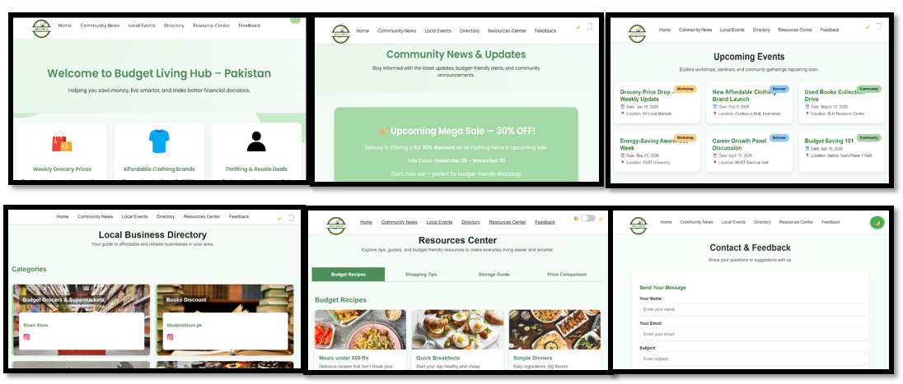
- Welcome Page
- Community New Page
- Local Events Page
- Directory Page
- Resources Center Page
- Contact and Feedback Page

Group Roles & Contributions
- Aiman Nasir: Designed the Welcome Page and Local Markets Page.
- Faryal Shakeel: Created the Discount Offers Page and Contact Page.
- Aisha Irshad: Developed the Product Comparison Page and About Us Page.
- All Members: Collaborated on testing, responsiveness, and final review.

Challenges Faced
- Implementing dark mode without JavaScript.
- Making the website fully responsive on different devices.
- Ensuring images load correctly and align properly in all sections.
- Maintaining consistent color schemes for readability.

Conclusion
This project helped us understand the real-life impact of inflation and how technology can assist people in making better purchasing decisions. By creating a responsive, informative, and user-friendly website, we not only improved our web development skills but also learned how to work as a team to solve problems effectively. Budget Living Hub is a practical tool that can help people save money and access quality products easily.

